PROJECT TITLE
Financial Sector Stock Market Analytics:
Real-Time EDA, Risk & Return Insights using Python and Power BI
- Project Overview and Objective
This project involves cleaning, transforming, and analysing live NSE financial-sector stock data using Python and creating an interactive Power BI dashboard to compare price, volume, returns, volatility, and risk-adjusted performance across Banking, NBFC, and Insurance stocks.
The main objective is to demonstrate data pre-processing in Python (pandas / numpy), statistical ranking of 15 NSE stocks, and an interactive Power BI dashboard so investors and analysts can make informed decisions using return per unit of risk rather than rupee Close alone.
- Data Sources
- Source Description: Yahoo Finance, accessed live via the yfinance Python package - free, no API key required.
- Timeline: Historical stock market data covering approximately the last five years (rolling 5-year window), fetched live from Yahoo Finance up to the most recent available trading date.
- Domain: Financial sector - Banking,NDFC & Insurance
- Problem Statement
- To gather, clean, transform, and pre-process historical stock market data of selected banking, NBFC, and insurance companies to ensure accurate and reliable analysis.
- To conduct Exploratory Data Analysis (EDA) using Python in order to examine price movements, trading volume trends, returns, volatility, seasonality, and key market fluctuations over the past five years.
- To evaluate and compare the risk, return, and correlation characteristics of financial sector stocks across banking, NBFC, and insurance segments, with the aim of identifying top-performing stocks and diversification opportunities.
- To develop insightful visualizations and generate actionable findings and recommendations that enable stakeholders to better understand the performance, trends, and market behavior of banking, NBFC, and insurance stocks.
4. Attribute (Column /Features) Details:

Attribute Name | Data Type | Description
Date | Date | The specific trading date on which the stock market data was recorded. It is used to analyze stock price movements and trends over time.
Open | Numeric (Float) | The price at which the stock started trading at the beginning of the trading day.
High | Numeric (Float) | The highest price reached by the stock during the trading day.
Low | Numeric (Float) | The lowest price reached by the stock during the trading day.
Close | Numeric (Float) | The price at which the stock ended trading at the end of the trading day. It is commonly used to analyze stock performance and calculate returns.
Volume | Numeric (Integer) | The total number of shares traded during the trading day. It indicates the level of trading activity or market interest in the stock.
Ticker | Categorical(Text) | The unique stock-market symbol used to identify a particular company, such as HDFCBANK, ICICIBANK, or SBIN.
Company_Name | Categorical(Text) | The full name of the company associated with the stock ticker.
Segment | Categorical(Text) | The financial-sector category to which the company belongs, such as Banking, NBFC, or Insurance.
Exchange | Categorical(Text) | The stock exchange where the company's shares are traded, such as NSE.
Currency | Categorical(Text) | The currency in which the stock prices are reported, such as INR (Indian Rupee).
5. Tools & Technologies
- Python: Data cleaning, transformation, yfinance, pandas, numpy, matplotlib, seaborn, Github.
- Power BI: DAX calculations, visualization, and interactive dashboard creation.
6. Data Pre-Processing (Python)
Tasks Performed:
- Data Cleaning & Transformation: Removed duplicate rows; coerced Date and OHLCV types; imputed numeric gaps with per-ticker median; dropped rows with missing identifiers; removed invalid OHLC (High < Low, Close outside Low–High, negative prices/volume). Created Daily_Return_Pct, Price_Range, Year, Month, Month_Name, Weekday, and Rolling_Volatility_30d. Cleaned file: 18,458 rows × 18 columns.
- Filtering & Sorting: Sorted by Ticker and Date; dropped the first return/volatility rows per ticker (NaN until a prior close and min_periods=5 existed). Focused the dashboard on Bank / NBFC / Insurance via Segment and Year slicers.
- Tables: Built statistical_summary.csv as the ranking table (mean return, volatility, risk-adjusted score, SMA 50/200 trend) — the Power BI StockSummary lookup. Daily returns were also pivoted by Date × Ticker for the correlation heatmap.
- Convert the data into Fact and Dimension Table: StockData is the fact table (one row per ticker per trading day). StockSummary is the dimension / lookup table (one row per ticker: Rank, Risk_Adjusted_Score, Trend). Relationship: StockData[Ticker] many-to-one StockSummary[Ticker].
- Charts (Python)

Chart 1 — Closing price trend by stock
It shows the 5-year closing-price journey of all 15 stocks together. Rising lines mean the stock became more expensive; falling lines mean it declined. High-priced names (for example Bajaj Finance) sit near the top of the axis, while cheaper PSU banks sit near the bottom — so this chart compares price level, not percentage performance.

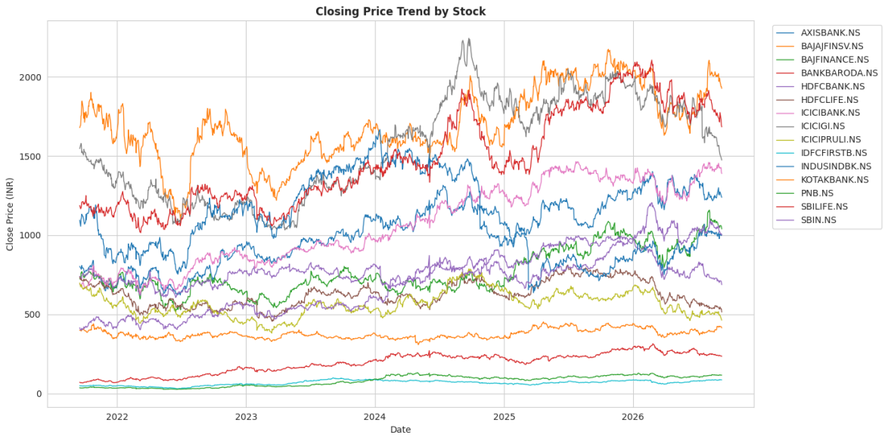

Chart 2 — Average daily trading volume
Tall bars are the most actively traded (more liquid) names. Short bars are quieter and may be harder to buy or sell in size. Liquidity and price level are different ideas: a cheap stock can still have huge volume.

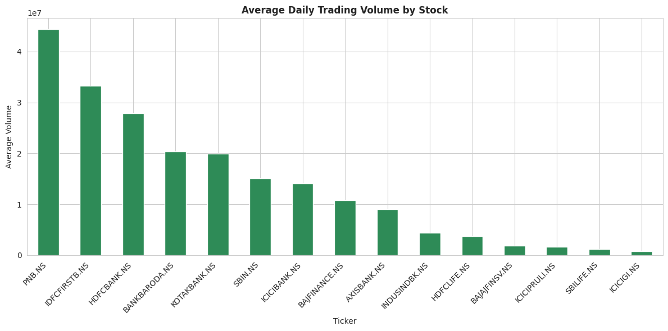

Chart 3 — Average closing price by segment
The three sub-segments do not trade at the same rupee price level. A taller bar only means that segment’s stocks are more expensive on average, not that they delivered better returns.

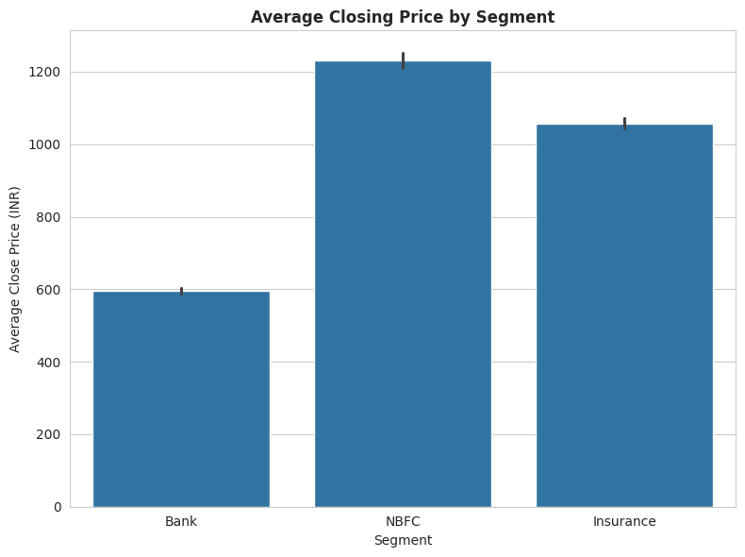

Chart 4 — Daily return distribution by segment (box plot)
A taller / wider box means that segment’s returns swing more — higher volatility (risk). A tight box means more stable day-to-day moves. This is a risk comparison, not a “who made more money” ranking.

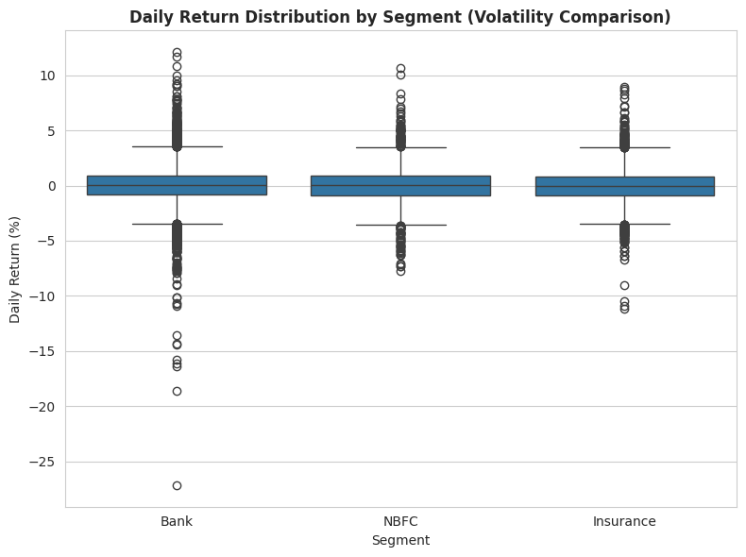

Chart 5 — Correlation heat-map of daily returns
It shows co-movement. Bank names often move together (same rate/credit news). A pair with r ≥ 0.7 gives little diversification if you hold both. A pair near 0 is a better diversifier inside the financial sector.

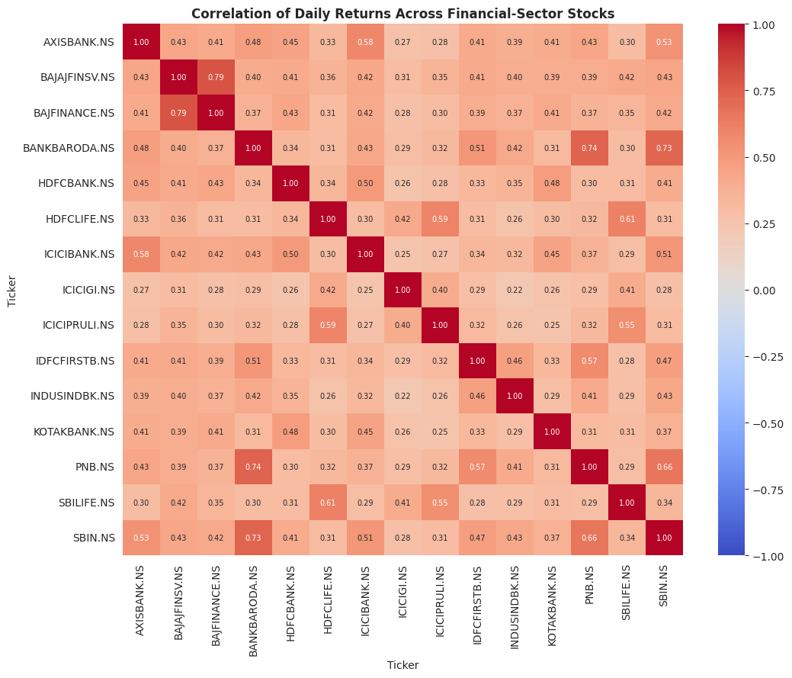

Chart 6 — Risk vs. return scatter
Ideal names sit top-left (higher return, lower risk). Bottom-right is poor risk-reward (volatile without extra return). A stock with a high average return can still be unattractive if it sits far to the right (very volatile).

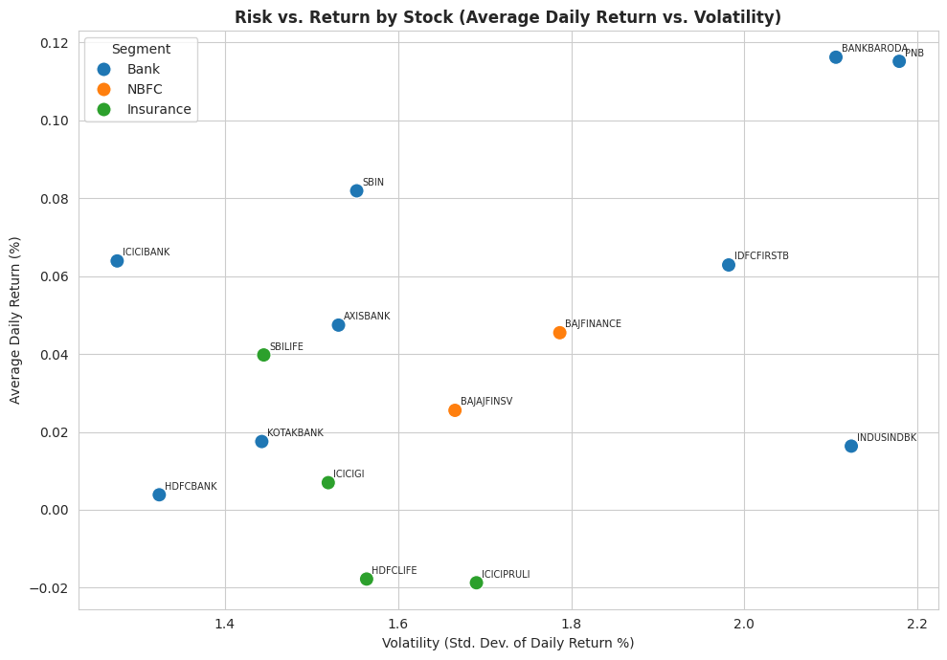

Chart 7 — Risk-adjusted performance ranking
Raw return can mislead. This re-ranks the 15 stocks by efficiency — how much return was earned per unit of risk. The top bar is the most efficient name in this basket; the bottom bar is the weakest.

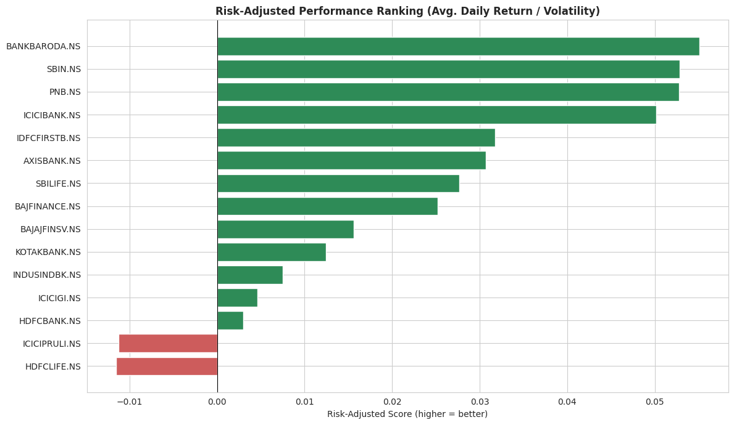

Chart 8 — Price with SMA 50 / SMA 200 (best risk-adjusted stock)
If the latest Close is above both averages, the stock is in an uptrend. Below both is a downtrend. Mixed/sideways means it sits above one average and below the other. The ranking said this name was efficient historically; this chart checks whether the current trend is still healthy.

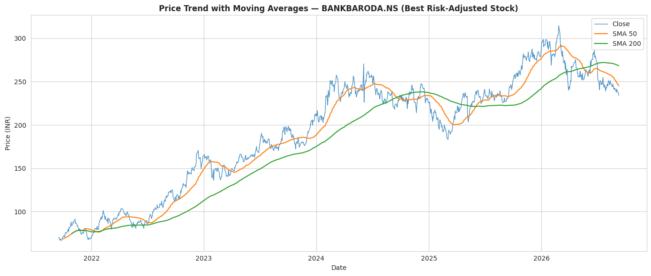
8. Analysis and Visualizations (Power BI)
Dashboard Features:
- Multiple Visualizations based on problem statement: Bar charts, line charts, pie charts, cards, and Images from python,slicers.
- Dashboard 1 — Price & Volume: slicers (Name, Segment, Year); KPI cards (Avg / Max / Min Close, Avg Volume); line chart of Close over Date; column chart of average Close by Segment; bar chart of average Volume by stock; area chart of Price_Range over Date.

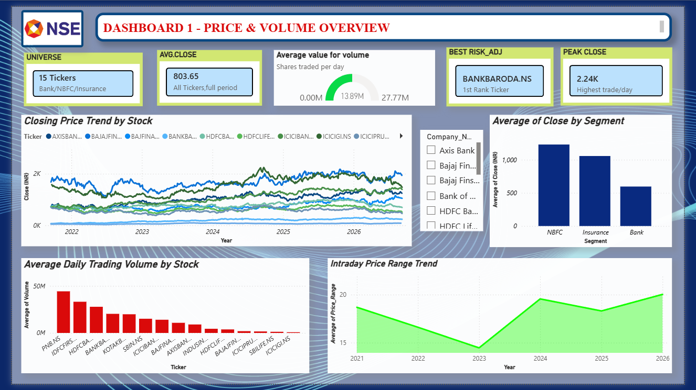

- Dashboard 2 — Returns & Risk: KPI cards (Avg Daily Return, Positive Return Days, Avg Rolling Volatility, Stock Count); line of daily return %; volatility bars; average return by Segment; donut of positive-return days by Segment; risk-adjusted score bars.
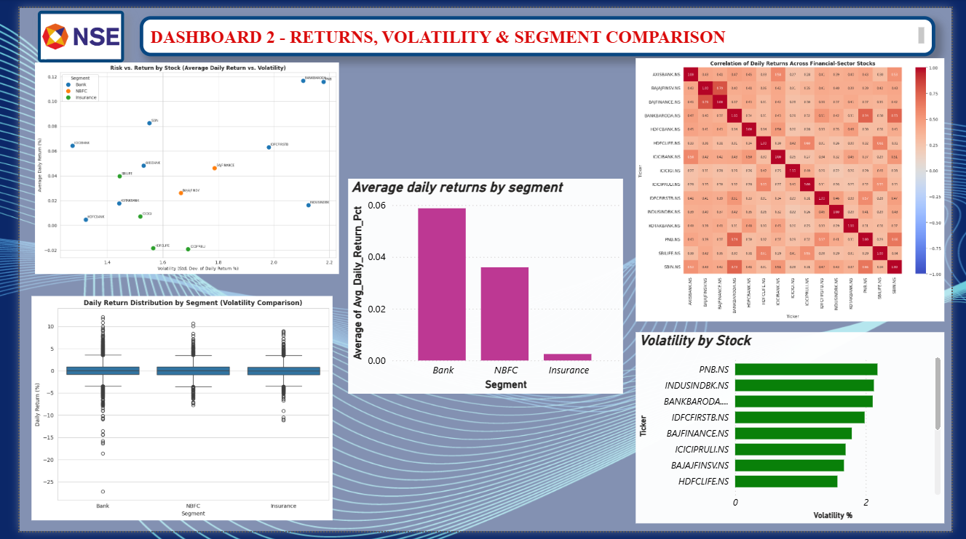

- Dashboard 3 — Scorecard: KPI cards (Rank 1 = BANKBARODA, Best Score, Uptrend / Downtrend / Mixed counts, Best Return %); ranking bars; trend donut; raw-return bars.

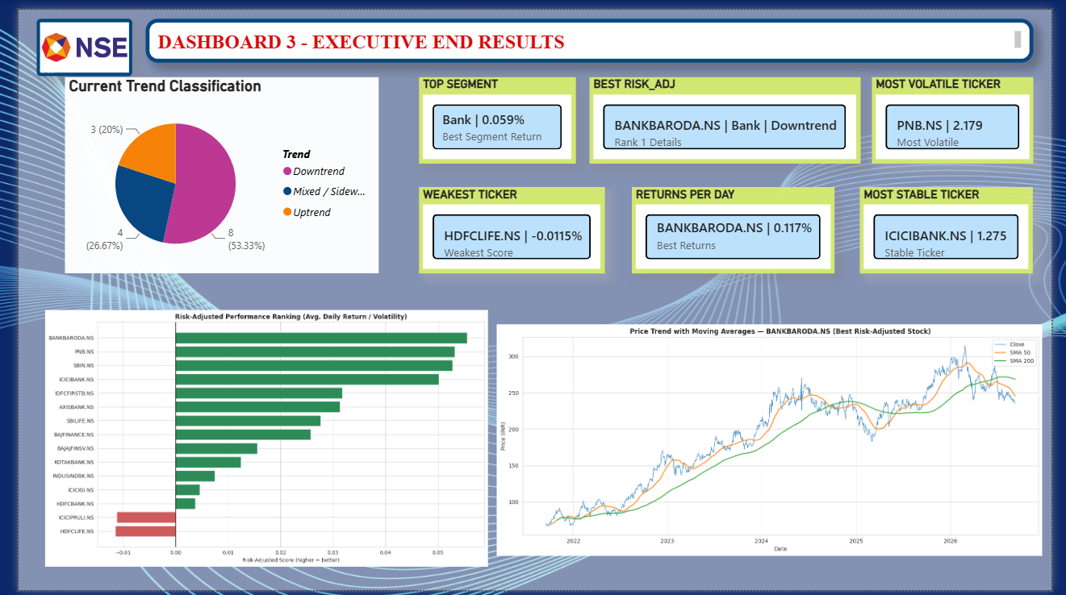
9. Insights & Conclusions
- Key Findings: Over five years, Bank of Baroda (BANKBARODA.NS) had the best risk-adjusted score (0.057) and average daily return 0.120%, but its SMA 50/200 label is Downtrend. PNB is Rank 2 (score 0.055, same 0.120% return) and is in an Uptrend. Insurers lag: HDFC Life and ICICI Prudential Life have negative average daily returns. 8 of 15 names are Downtrend; only 3 are Uptrend (PNB, IDFC First Bank, Kotak Bank). Bajaj Finserv and Bajaj Finance move closely together, so they are weak diversifiers if held as a pair.
- Analysis insights:
1. Descriptive analysis
- Universe: 15 NSE stocks (9 Bank, 2 NBFC, 4 Insurance). Raw fetch: 18,597 rows, 09 Sep 2021 – 09 Sep 2026. After cleaning and dropping the first return/volatility rows: 18,441 rows, 18 columns, 20 Sep 2021 – 09 Sep 2026.
- BANKBARODA had the highest average daily return (0.120%) and the best risk-adjusted score (0.059). PNB matched that 0.120% return with slightly higher volatility (2.179 vs 2.106), so it ranks #2.
- Liquidity is concentrated in large banks: PNB (~44 million average shares/day), IDFC First Bank, HDFC Bank, Bank of Baroda. Insurers such as ICICI Lombard trade far fewer shares.

2. Diagnostic analysis
- Banks dominate the top of the ranking (Ranks 1–6 are all banks except the insurance/NBFC names that appear from Rank 7). Insurance occupies the bottom: ICICIGI Rank 12, HDFCLIFE Rank 14, ICICIPRULI Rank 15 with negative average daily returns.
- High PSU-bank returns came with wider daily swings. PNB is the most volatile; ICICIBANK is the most stable (σ ≈ 1.275%) and still Rank 4 because its return/risk ratio stays strong.
- Chart 5 (correlation heatmap) shows co-movement inside the financial sector. BAJAJFINSV and BAJFINANCE are the tightest pair (same promoter group) — they explain each other’s moves, so they do not hedge each other.
- Raw Close charts overstate expensive names. That is why Stage 2 engineered `Daily_Return_Pct` and Stage 3 ranked `Risk_Adjusted_Score` instead of rupee price.

3. Predictive analysis
- This is a trend snapshot (SMA 50 vs SMA 200), not a price-forecast model.
- 3 Uptrend: PNB, IDFC First Bank, Kotak Bank.
- 4 Mixed / Sideways (including ICICI Bank).
- 8 Downtrend (including Rank 1 Bank of Baroda, SBI, Axis Bank, HDFC Bank, and the weaker insurers).
- Rank 1 BANKBARODA is Downtrend — historically efficient, but the latest moving averages do not confirm an uptrend.
- Rank 2 PNB is Uptrend, so among the top scores it currently has the cleaner trend filter.

4. Prescriptive analysis
- Prefer risk-adjusted rank + trend together: PNB (Rank 2, Uptrend) is the more complete long idea than Bank of Baroda (Rank 1, Downtrend) if momentum matters.
- Do not pair Bajaj Finserv with Bajaj Finance for diversification; pick one or offset with a lower-correlation name.
- Treat HDFC Life and ICICI Prudential Life as laggards over this window — they do not lead this financial-sector basket.
- Use volume as a liquidity filter before acting on a return rank: high-volume banks are easier to enter and exit than quieter insurers.
- Re-run Stages 1–4 after a data refresh; ranks and SMA labels will move as new daily bars arrive.

10. Conclusions
    - From the analysis, we identified meaningful relationships and patterns in the 15 NSE financial-sector stocks. The Python charts and the three Power BI dashboards highlight the main factors that should drive a decision in this basket: return per unit of risk, current SMA trend, liquidity, and co-movement.
    - Bank of Baroda delivered the strongest risk-adjusted performance over five years (score 0.059), but it is currently in a downtrend. PNB is close behind on score (0.053) and is in an uptrend. Banks outperformed NBFCs and insurers on average daily return. Bajaj Finserv and Bajaj Finance should not be held together for diversification. Rank by return per unit of risk — not by rupee Close — and re-check SMA 50 / SMA 200 before treating a historical winner as a current buy.
    - These three dashboards, built from financial_sector_stock_data_cleaned.csv and statistical_summary.csv, are the Stage 4 visual and decision deliverable.

